 |  |  | 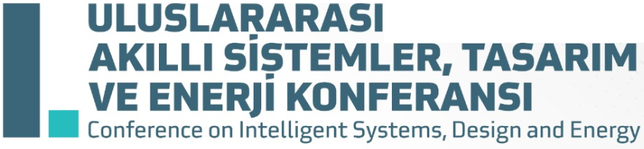 | 
TITLE OF STUDY TITLE OF STUDY TITLE OF STUDY TITLE OF STUDY TITLE OF STUDY TITLE OF STUDY TITLE OF STUDY TITLE OF STUDY TITLE OF STUDY TITLE OF STUDY
Name SURNAME ¹ , Name SURNAME ^{1*} Name SURNAME ²
¹ Bitlis Eren University, Mechanical Engineering Department, Bitlis, Türkiye
² Bitlis Eren University, Electric and Electronic Engineering Department, Bitlis, Türkiye
* Corresponding Author: mail@beu.edu.tr
 | ABSTRACT
An abstract is an essential component of every scientific study. It should briefly summarize the reason for the work, the main purpose, findings, foremost results, and main conclusions of the study. The purpose of the abstract is to offer a quick insight into the study’s content, allowing readers to assess its relevance and significance. The abstract should not contain figures, tables, elaborate equations, references or non-standard or rarely used abbreviations. If it is necessary to include them, make sure they are clearly defined upon their first appearance in the abstract.
The abstract text should be written using the “Aptos” font type, with a font size of 10 The text should be justified. Line spacing should be 1, with a spacing of 6 nk before and after the line. The abstract text should not exceed 500 words. The abstract should be written within the provided table. Please ensure that the table settings are not changed. A minimum of three (3) and a maximum of six (6) keywords should be included. Keywords must be relevant to the study's topic and content, separated by commas, with a full stop after the final keyword. Only the first word and proper nouns should start with a capital letter. Although not mandatory, authors are encouraged to provide a graphical abstract. It should visually convey the key message of the study in a clear and engaging manner, making it accessible to a broader audience. Including a graphical abstract can boost your article's visibility and aid readers' understanding of your research. If included, the graphical abstract should be placed before the introduction without a separate heading. It should have a maximum width of 15 cm, not exceed one page in length, and be prepared with a resolution of at least 300 dpi to ensure high-quality presentation.
 | Keywords: | Keyword for study, PROPER NOUN KEYWORD, Bitlis Eren University (BEU), Element₂ keyword, Keywords, Keyword.

